|  |  |
| --- | --- |
|  | **Qatar University**  **College of Engineering** |

Software Engineering Lab

Milestone 2

Library System Project

CMPS310

01/12/2025

* Student Names:

**SID:** 202208914 - **STUDENT NAME:** Ruaa Elshiekh - Effort given: 25%

**SID:** 202204518 - **STUDENT NAME**: Salsabeel Bahr - Effort given: 25%

**SID:** 202206112 - **STUDENT** **NAME:** Iman Khabz - Effort given: 25%

**SID:** 202203792 - **STUDENT** **NAME:** Amira Sheikh - Effort given: 25%

DECLARATION: We hereby certify that no part of this project or product has been copied from any other student’s work or from any other sources except where due acknowledgment is made in the project. No part of this project/product has been written/produced for us by any other person.

Table of Contents

Section 1: 3

1. Updated Class Diagram: 3

1.1. Updated Parts: 3

2. Use Case Specifications: 4

2.1. Apply for Membership: 4

2.2. Reserve an Item: 5

Section 2: 6

3. Task 1: Sequence Diagram: 6

3.1. Apply for Membership: 6

3.2. Reserve an Item: 7

4. Task 2: Constraints and Quality Properties: 8

4.1. System Constraints: 8

4.2. Quality Requirements (Non-Functional Requirements): 11

5. Task 3: Implementation of Two Use Cases Using JavaFX: 13

5.1. Main Menu: 13

5.2. Apply for Membership: 13

5.3. Reserve Item: 19

6. Task 4: Testing the Program Using JUnit Testing: 22

6.1. MembershipControllerTest: 22

6.2. ModelLogicTest: 23

6.3. ReservationControllerTest: 24

7. Task 5: Testing two Quality Requirements (NFRS): 25

7.1. Usability: 25

7.2. Reliability: 27

8. Task 6: Applying two Design Patterns: 30

8.1. Factory Pattern 30

8.2. Facade Pattern: 32

Section 3: 35

9. Conclusion: 35

10. Resources: 36

10.1. GitHub Link: 36

10.2. Snapshot from GitHub Page: 36

# Section 1:

## 1. Updated Class Diagram:

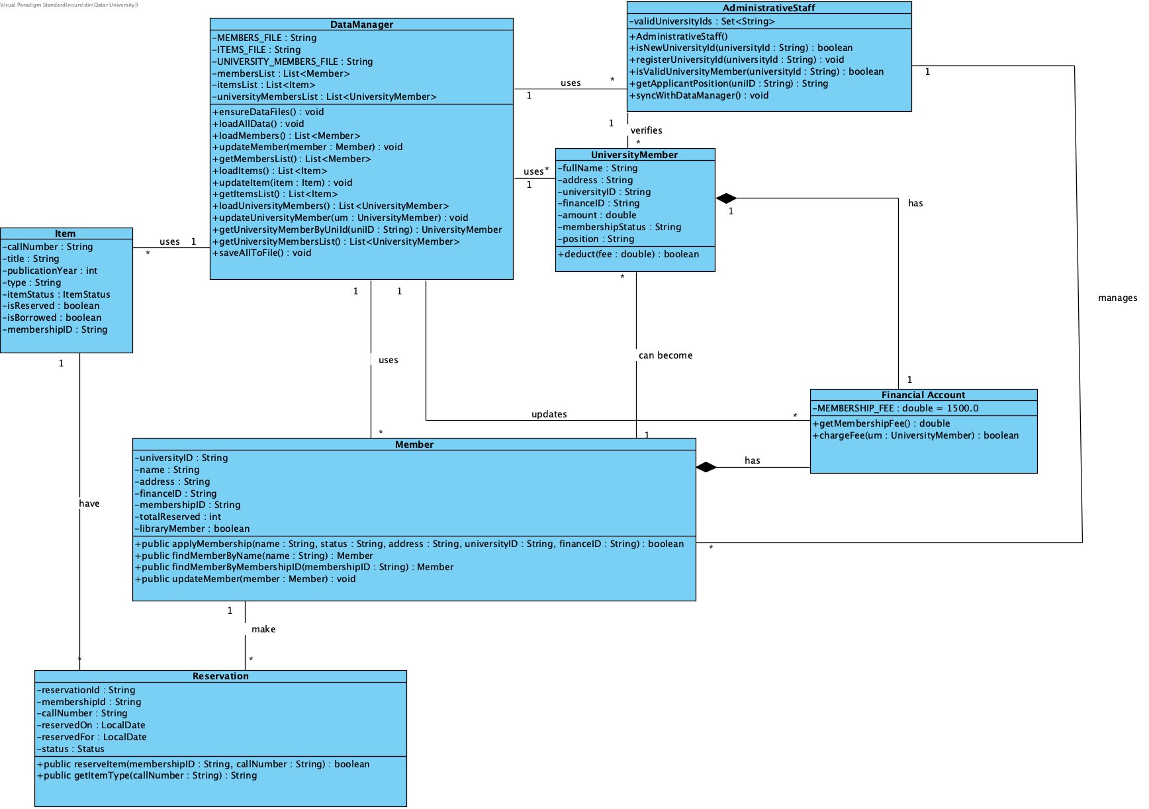

### 1.1. Updated Parts:

In revising the class diagram for our library management system, several changes were made to better support the JavaFX implementation and improve overall system organization. Specifically, some classes such as Applicant and Loan were removed from the diagram as their functionality could be handled within the existing controllers or through static utility methods in DataManager. On the other hand, new classes including UniversityMember and DataManager were added and some methods were modified in some classes like Item, Reservation and Member. These additions provide a clear separation of concerns and facilitate interaction with the JavaFX GUI. This restructuring not only simplifies the code but also aligns the system design with JavaFX’s event-driven architecture, making it easier to manage user input, update the interface, and maintain data consistency across the application.

## 2. Use Case Specifications:

### 2.1. Apply for Membership:

|  |  |
| --- | --- |
| **Use Case ID:** UC001 | **Apply for Membership** |
| **Brief Description** | Applicant submits a membership application with his details and a payment is requested. Once payment is made, a membership card is created. |
| **Primary Actors** | Applicant (Student/Staff), Administrative Staff, PearlSys, FinanceSys. |
| **Trigger** | Applicant submits membership application form online. |
| **Preconditions:**   1. Library system, Pearlsys are available. 2. Pearlsys is accessible by the library system. 3. A valid form is submitted, with a valid name, address and a university Finance_Account. 4. Must be a staff or a student of the university. | |
| **Post-conditions:**   1. The system creates a library membership account if the transfer is successful. 2. A membership card is issued with a unique membership number and is sent to the new member. | |
| **Main Success Scenario:** A membership card is issued with a unique membership number and is sent to the new member. | |
| **Actor Action** | **System Response** |
| 1. Applicant submits an online application with their name, address and university Finance_Account. | 1. Notifies library administrative staff. |
| 1. Administrative staff reviews the application and provides any necessary input. | 1. Updates application information. |
|  | 1. Communicates with Pearlsys to verify that the applicant is a university member. |
| 1. Pearlsys sends applicants identity confirmation. | 1. Records the feedback and accepts university members (see 6.a. for alternative). |
|  | 1. Requests 1500 QAR from FinanceSys. |
| 1. FinanceSys transfer QAR 1500 from applicant’s Finance_Account. | 1. Creates a membership account & deposits funds. (see 10.a. for alternative). |
| 1. FinanceSys updates the applicant’s Finance_Account. | 1. Issues a membership card with a unique membership number. |
|  | 1. Sends the new membership card to the new member. |
| **Alternative Flows:** 6.a. If the feedback shows that the applicant is not a university member, the system rejects them.  10.a. If the transfer fails, the system generates an error message asking to provide a valid Finance_Account. | |

### 2.2. Reserve an Item:

|  |  |
| --- | --- |
| **Use Case ID:** UC004 | **Reserve an Item** |
| **Brief Description** | A member can reserve an item if it is borrowed by another. Member scans their card, and the item is reserved under member’s account. |
| **Primary Actors** | Member. |
| **Trigger** | Member scans membership card and provides the call number of the item they would like to reserve. |
| **Preconditions:**   1. Must be a valid member with a valid membership card. 2. System must be available and accessible. 3. Member must have fewer than 3 active reservations. 4. Item number must be a valid number that exists within the system. 5. Item must not be reserved by someone else. | |
| **Post-conditions:**   1. Item is reserved under the member’s account. 2. Total reserved items count is increased by one. 3. System confirms reservation to the member. | |
| **Main Success Scenario:** Item is reserved by member, and the total reserved items count increases by one. | |
| **Actor Action** | **System Response** |
| 1. Member scans their membership card. | 1. Retrieves their account details. |
|  | 1. Checks total number of items member has reserved (see 3.a. for alternative). |
| 1. Member provides call number of the item. | 1. Retrieves the item details. |
|  | 1. Checks the availability of the item (see 6.a. for alternative). |
|  | 1. Reserves item under the member’s account. |
|  | 1. Increases the total reserved items count by one. |
|  | 1. Confirms the reservation to the member. |
| **Alternative Flows:**  3.a. If the member has reached the limit of three reservations, no additional reservations are allowed, and the system cancels the reservation and shows an error to the member.  6.a. If the item is reserved by someone else, the system shows an error to the member, and the reservation process is cancelled. | |

# Section 2:

## 3. Task 1: Sequence Diagram:

### 3.1. Apply for Membership:

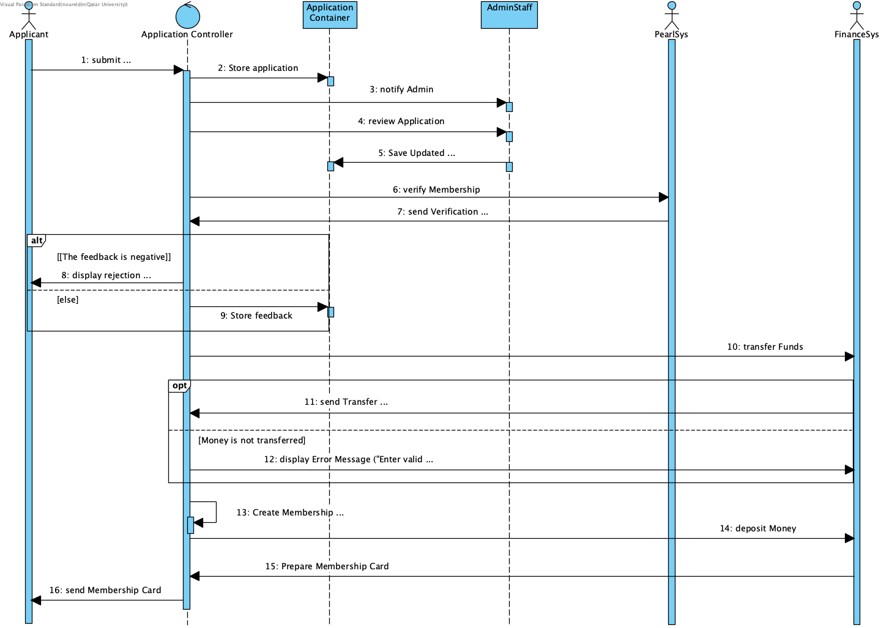

### 3.2. Reserve an Item:

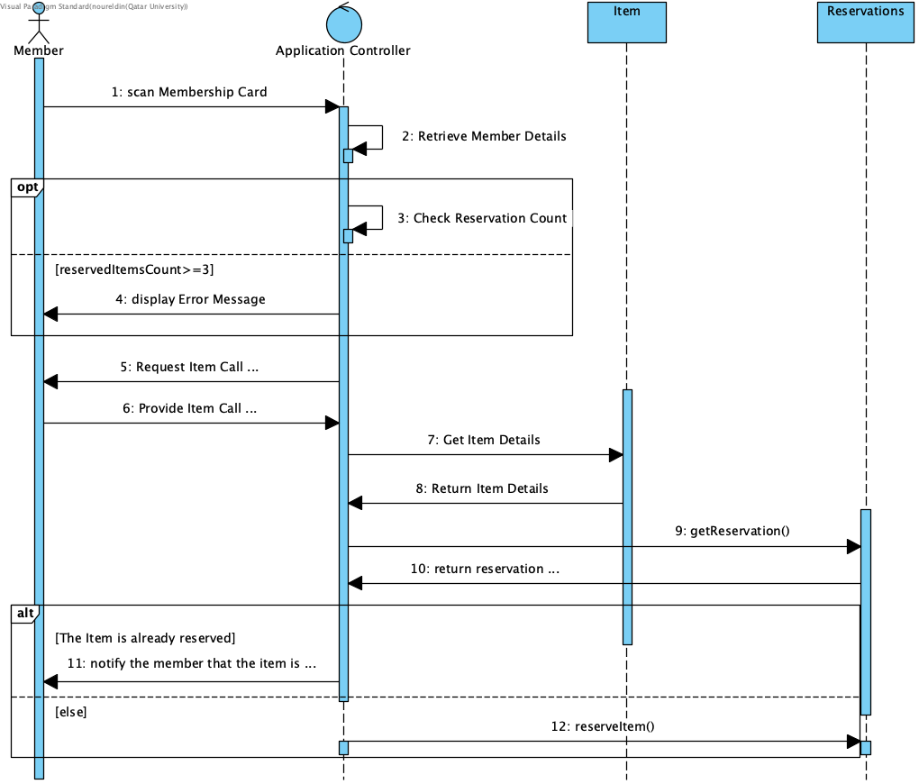

## 4. Task 2: Constraints and Quality Properties:

### 4.1. System Constraints:

#### 4.1.1. Business Constraints:

* Constraint: Only Gulf Pearl University students and staff are eligible for library membership.
  + Evidence: “Only staff or students of Gulf Pearl University are eligible to borrow items from the library”.
* Constraint: Membership requires a 1500QR deposit.
  + Evidence: “the library system requests FinanceSys to transfer QR 1500 from the applicant’s Finance_Account to the library”.
* Constraint: members cannot borrow more than 5 items at a time.
  + Evidence: “Members may borrow a maximum of five items at a time”.
* Constraint: members cannot reserve more than 3 items at a time.
  + Evidence: “if the member has reached the limit of three reservations, no additional reservations are allowed”.
* Constraint: only 3 item categories and they have fixed loan period. Books (4 weeks), Digital Media (1 week), Magazines (2 weeks).
  + Evidence: “Loan periods, if the item is available, are as follows: Books for 4 weeks, Digital Media for 1 week, and Magazines for 2 weeks”.
* Constraint: items overdue more than 7 days after the due date are classified as lost and QR 100 from the member’s deposit to the library through FinanceSys. (Overdue).
  + Evidence: “items that have not been returned within 7 days past their due date…updates the item’s status to ‘lost’. The system deducts QR 100 from the member’s deposit as a fine and requests FinanceSys to transfer this amount to the library”.
* Constraint: Some certain items are only in-library use and cannot be loaded outside the library.
  + Evidence: “Not all items are available for loan; some can only be used within the library”.
* Constraint: Extension requests are allowed only if request before the due date, if the item is not reserved by another member, and the extension is only for one week.
  + Evidence: “If the item was not reserved, the system extends the due date by one week…The system checks the current return date; extensions are only allowed if the request is made before the due date”.
* Constraint: The system must function as a plug-in for the registration system (using Google Firebase).
  + Evidence: “the system must function as a plug-in for the registration system, which uses Google Firebase for data management.”.

#### 4.1.2. Technical Constraints:

* Constraint: The system must be portable and run on multiple operating systems (Linux, Windows, macOS, iOS, and Unix).
  + Evidence: “that the system must be highly portable, capable of running on multiple operating systems such as Linux, Windows, macOS, iOS, and Unix”.
* Constraint: the system can only have one server.
  + Evidence: “funding is available for just one new server”.
* Constraint: library member must have unique member number, and each library item is assigned a unique six-digit call number.
  + Evidence: “The system then issues a membership card with a unique membership number…Each item is assigned a unique six-digit call number”.
* Constraint: system components must be loosely coupled with minimal inter-module dependencies.
  + Evidence: “The system’s components should be loosely coupled and focused, minimizing dependencies.”.

#### 4.1.3. Resource and Budget Constraints:

* Constraint: Only three new technical staff can be hired for the project.
  + Evidence: “only three new technical staff can be hired for the project”.
* Constraint: Funding is available for only one new server for deployment.
  + Evidence: “funding is available for just one new server”.

#### 4.1.4. Schedule Constraints:

* Constraint: The system must automatically perform daily overdue checks at 8 a.m.
  + Evidence: “Every day at 8 a.m., the library system automatically checks for items that have not been returned within 7 days past their due date”.
* Constraint: Pealsys verification occur immediately after membership application
  + Evidence: “The system immediately notifies a library administrative staff member once an application is submitted…then communicates with PearlSys to verify”.
* Constraint: FinancialSys deposit (1500QR) must occur promptly before approving the membership application.
  + Evidence: “Once the transfer is successful, the system creates a library membership account and deposits the funds there.”.

#### 4.1.5. Data Security Constraints:

* Constraint: Finance_Account data must be protected from unauthorized access.
  + Evidence: “Member payment information is confidential and must be protected from unauthorized access”.
* Constraint: Financial data must be stored securely on the backend and encrypted to guarantee privacy and security.
  + Evidence: “This data should be stored securely on the backend, separated from the user interface, and encrypted to ensure privacy and security”.
* Constraint: Only authorized administrative staff may review membership applications information and update them.
  + Evidence: “The administrative staff reviews the application and provides any necessary input. The system updates the application information”.

#### 4.1.6. Integrational Constraints:

* Constraint: The system must integrate with the PearlSys
  + Evidence: “The system updates the application information and then communicates with PearlSys to verify that...”.
* Constraint: The system must integrate with FinancelSys
  + Evidence: “the library system requests FinanceSys to transfer QR 1500...”.
* Constraint: The system must be interoperable and able to integrate with other university systems
  + Evidence: “multiple backup modules should be implemented to ensure high system availability for members”.

#### 4.1.7. Operational Constraints:

* Constraint: The system must maintain high availability with many backups modules
  + Evidence: “multiple backup modules should be implemented to ensure high system availability for members”.
* Constraint: The system and interfaces must remain consistent with any future upgrades.
  + Evidence: “certain functions may require upgrades or modifications, but the interfaces with the rest of the system should remain consistent.”.

### 4.2. Quality Requirements (Non-Functional Requirements):

#### 4.2.1. Scalability:

Scenario: During the first week of the semester, the system must handle up to 1000 concurrent user requests trying to borrow or reserve items, with transaction processing time not exceeding 3 seconds for each request.

#### 4.2.2. Usability:

The system provides an intuitive and user-friendly interface for library members, ensuring that all librarian processes are efficient and easy to perform.

Scenario: A new student using the system for their first time can successfully register for library membership, search for a book, and reserve it in under 2 minutes using the system's application interface.

#### 4.2.3. Reliability:

The system operates reliably and tolerant under various load conditions and system failures by handling:

* Any invalid inputs of the user.
* Financial transfers that must be completed correctly.
* Tracking loans, lost items, deposits, and fines.

Scenario: In case of a network interruption during a membership fee transfer via FinanceSys, the system must roll back the transaction to avoid any financial inconsistency and log the failure, ensuring no funds are lost from either the member's or the library's account.

#### 4.2.4. Security:

The system protects financial data from unauthorized access by encrypting the data and stores it securely on the backend, ensuring privacy and security and the application data and item records can only be accessed by authorized (administrative staff).

Scenario: An unauthorized user must be blocked because he is trying to access the member financial information database directly via a URL or network, and the attempt must be outlined as a security outcome, and ensuring no sensitive data being exposed.

Scenario: Only administrative staff can review the membership data and mark items to “lost”, so no member can change the items records.

#### 2.2.5. Modifiability and Maintainability:

The system maintains consistent interfaces even when modules change, uses loose coupling, and allow changes to functionality in the future.

Scenario: A developer was asked to change the loan period for Magazines from 2 weeks to 4 weeks, so he can implement, test, and deploy the change within three working hours, without touching the borrowing system for Books or Digital Media.

#### 4.2.6. Availability:

The system is controlled by many backup modules that support its high availability.

Scenario: If the server stops, the backup server and modules must automatically take over within 2 minutes, ensuring that users currently borrowing, reserving, or returning items can complete their transactions with a maximum interruption of 2 minutes.

#### 4.2.7. Interoperability:

The system integrates with PearlSys(validation), FinanceSys(payments), registration system, and other various systems

Scenario: When a student who has been ousted from the university, tries to reserve a book, the library system must communicate concurrently with PearlSys, identifying the student's inactive status, and immediately block his/ her borrowing process.

#### 4.2.8. Performance:

The system can handle from 400 to 1000 concurrent borrowing requests within two years and performs daily automated tasks running on time such as daily overdue check.

Scenario: Although during peak hours with 400 other members using the system at the same time, a member scans their card at a library cabin, the system retrieves and displays their whole borrowing history and current loans in 2 seconds.

#### 4.2.9. Portability:

The system is executed on several operating systems such as Linux, Windows, macOS, iOS, Unix.

Scenario: The development team, whose members use a combination of Windows, macOS, and Linux operating systems, must be able to compile, run, and test the entire library system on their local machines without any code changes related to OS.

## 5. Task 3: Implementation of Two Use Cases Using JavaFX:

After running the library app the system will show following interface:

### 5.1. Main Menu:

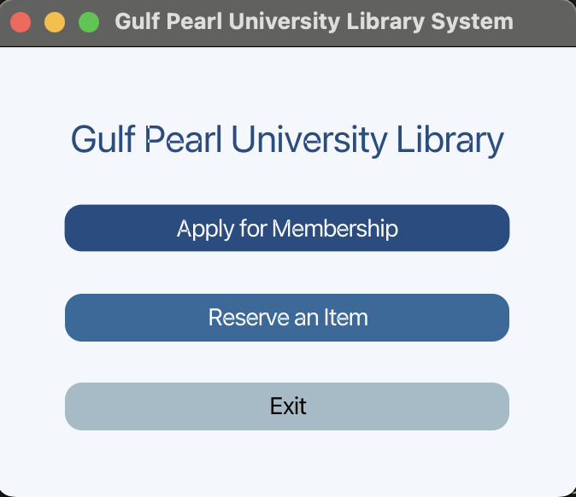

### 5.2. Apply for Membership:

Apply for membership Main Screen it has 5 fields each field the system checks for validity:

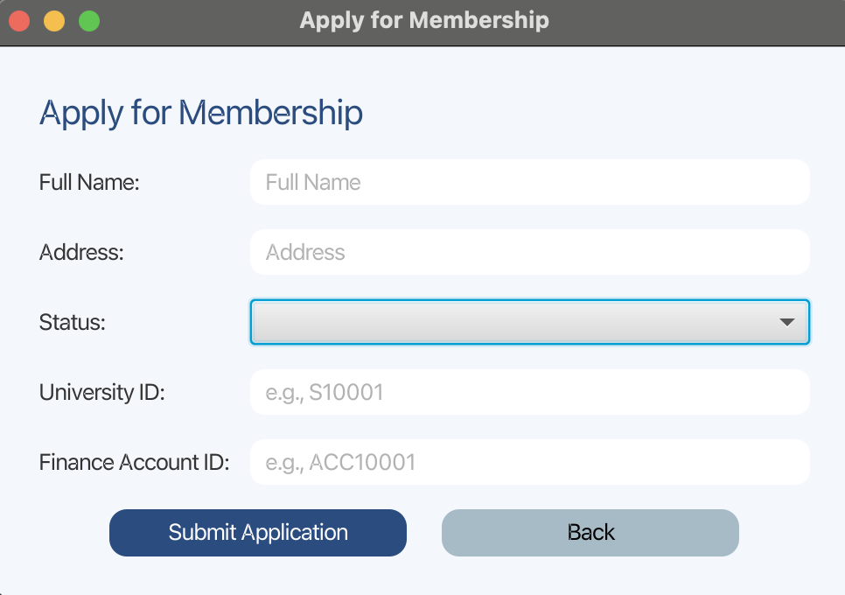

#### 5.2.1. Unsuccessful Membership Application:

When a user inputs numbers or invalid characters in “Full Name” the system shows an error:

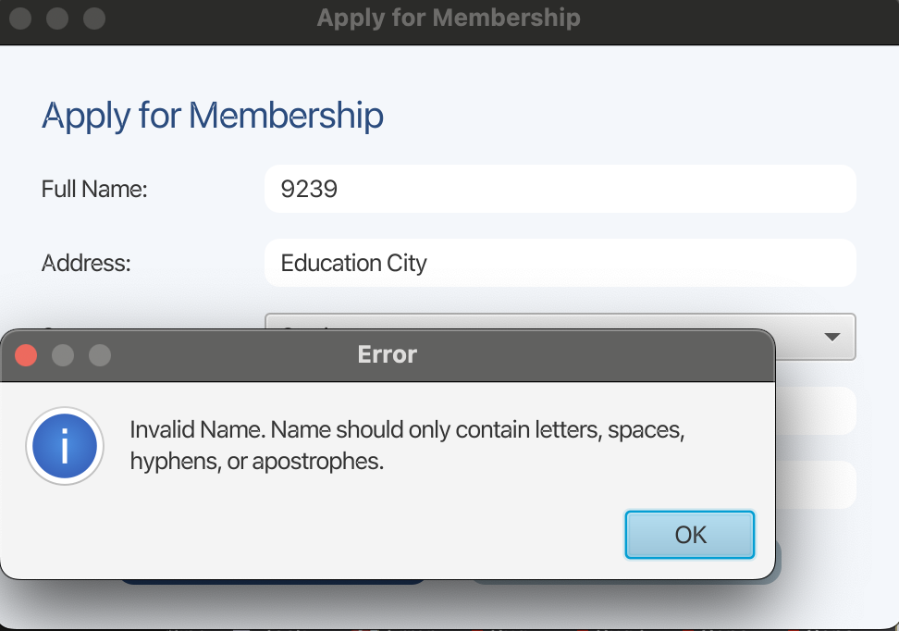

When a user enters invalid characters in “Address” the system shows an error:

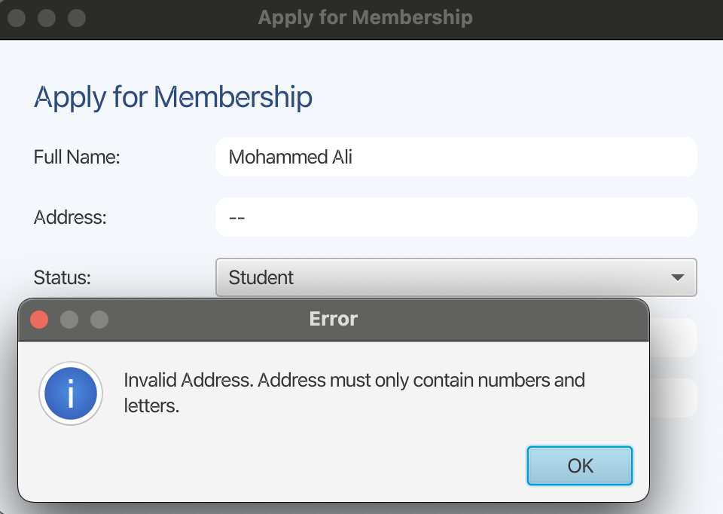

When a user inputs an incorrect “Address” that does not match the records, the system shows an error:

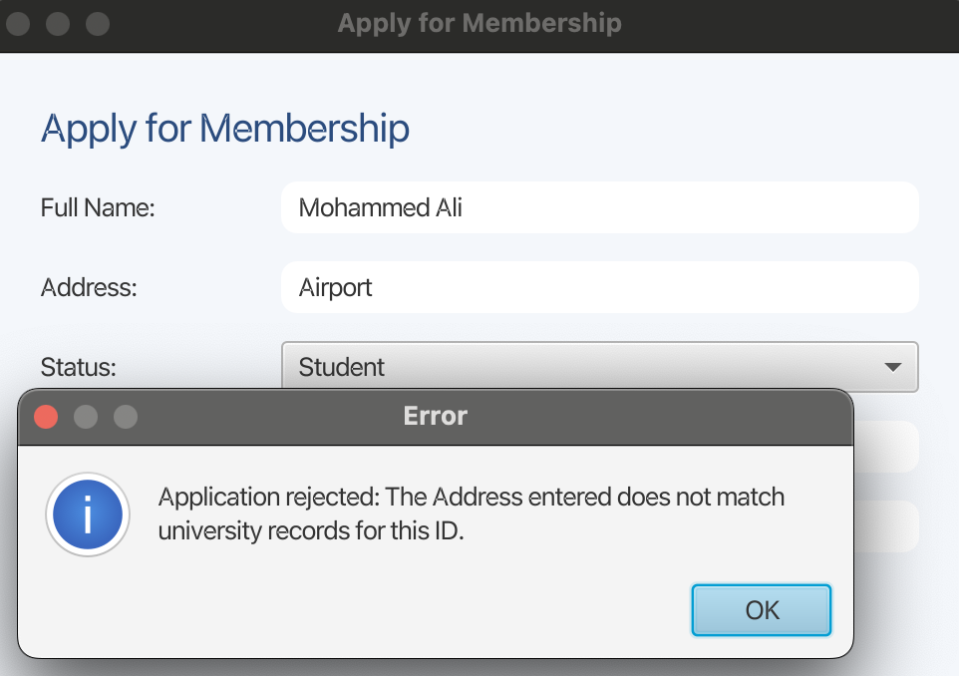

When a user inputs an incorrect “Full Name” that does not match the systems’ records, the system shows an error:

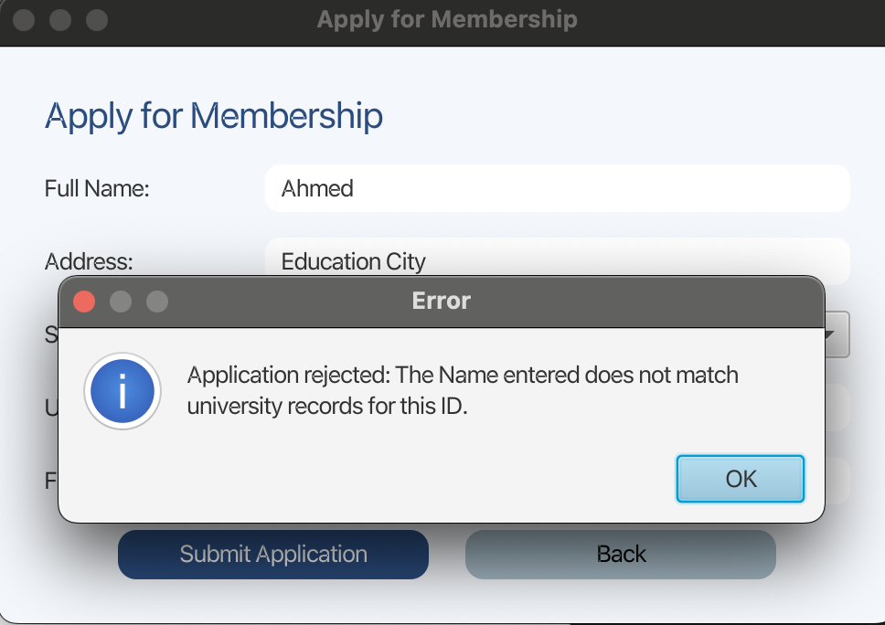

When a user is not a valid university member, the system shows an error:

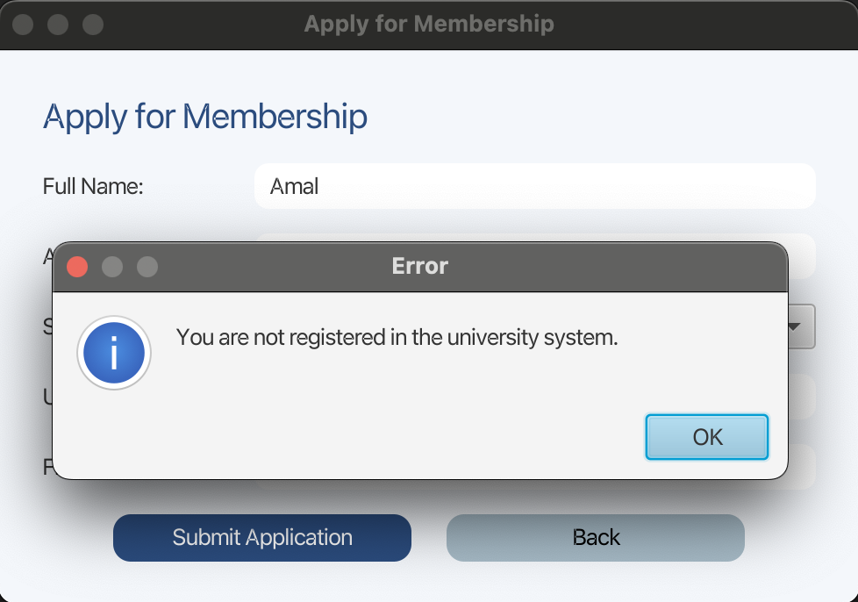

When some fields are left empty the system shows an error:

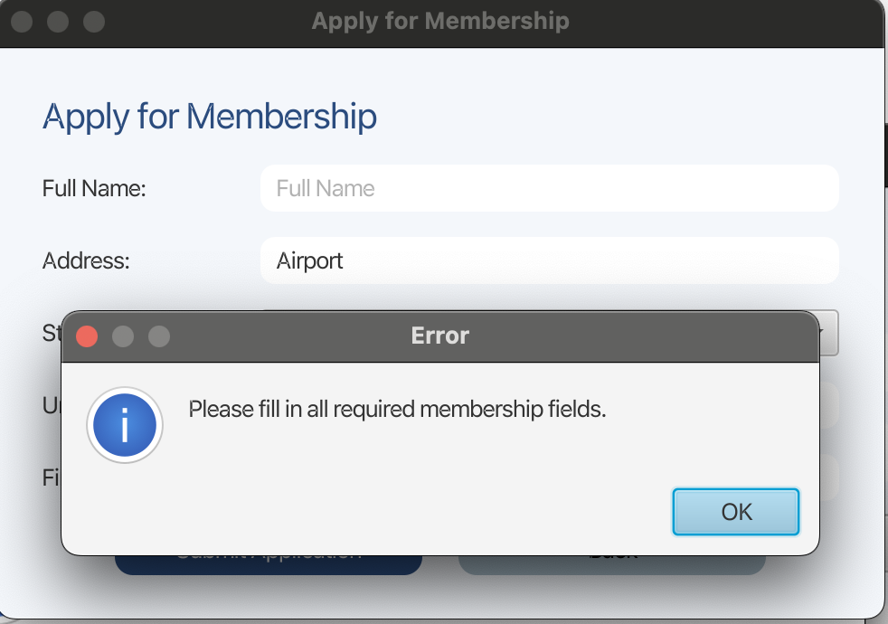

When an external user attempts to become a library member the system shows an error:

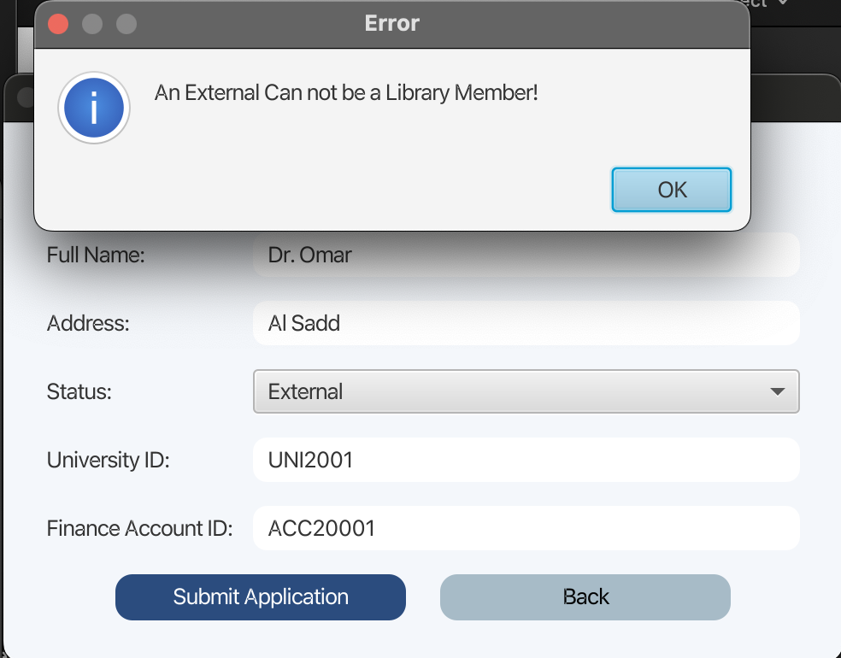

When a user inputs a false status, for example a staff chooses student instead of staff, the system shows an error:

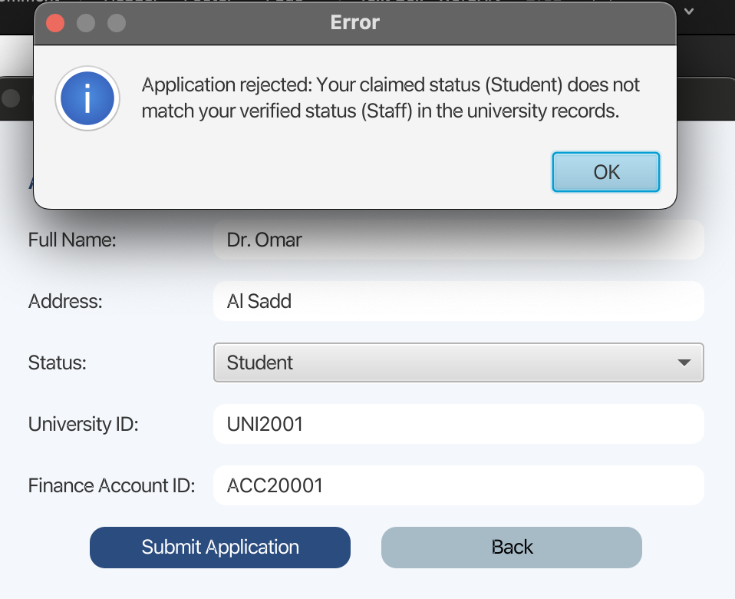

When a university member does not have sufficient balance to apply for membership the system shows an error:

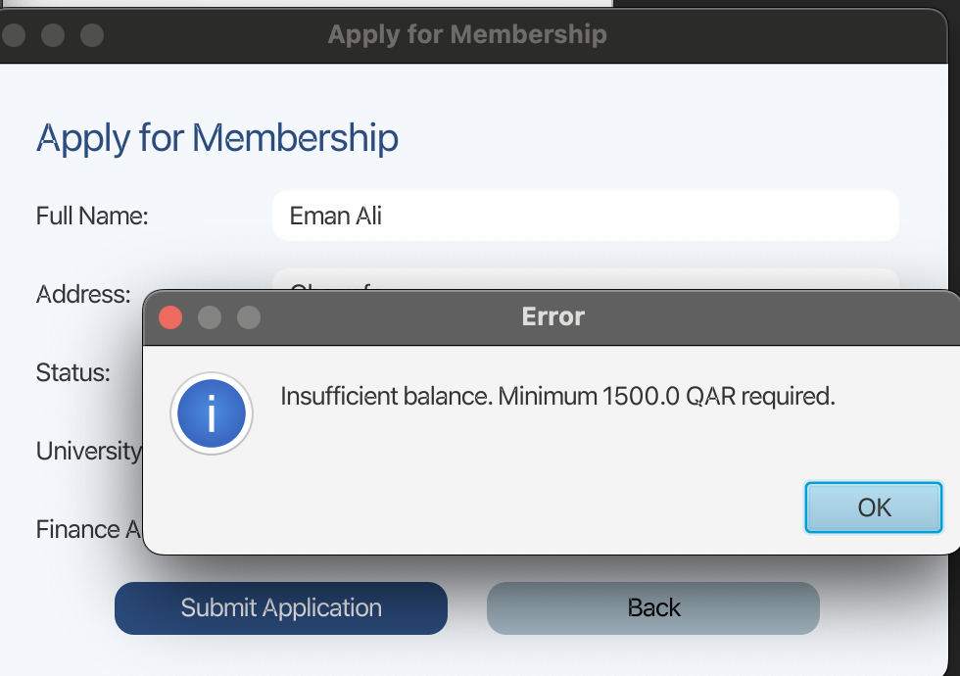

#### 5.2.2. Successful Membership Application:

When everything is correct and a user is indeed a university member with the sufficient balance, the system accepts their application and deducts 1500 from their financial account. The system creates a membership card with a unique ID:

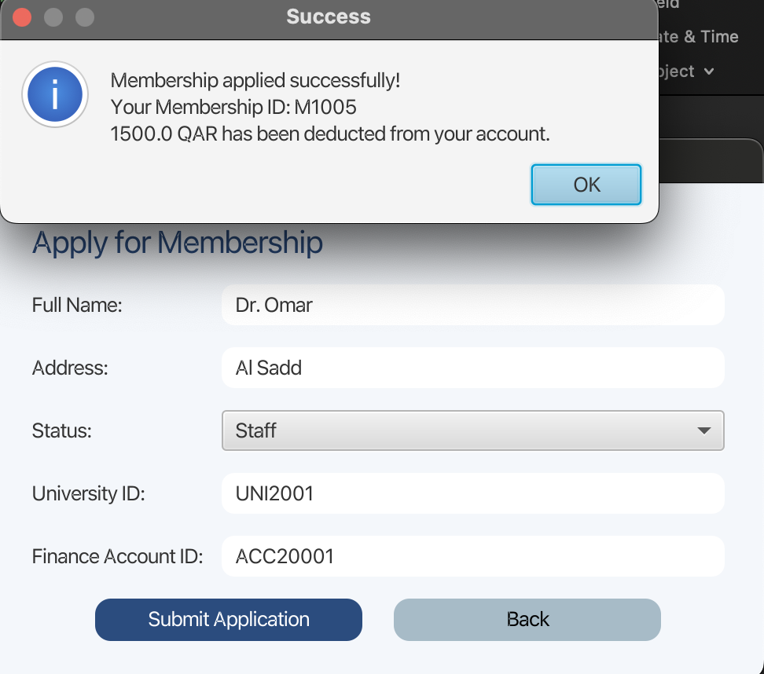

### 5.3. Reserve Item:

Reserve item Main Menu:

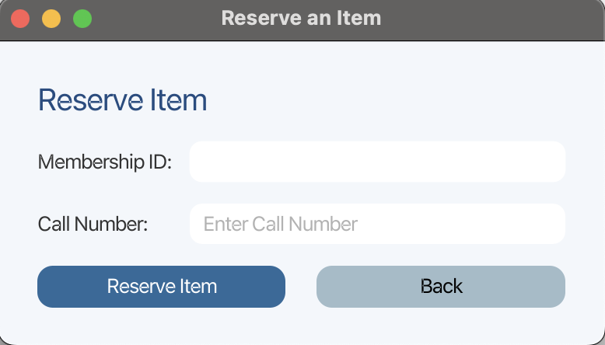

#### 5.3.1. Unsuccessful Item Reservation:

When a user inputs an incorrect library member, the system shows an error:

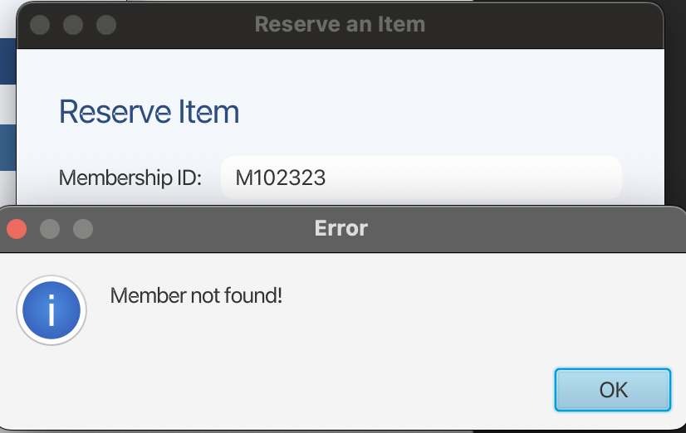

When a user inputs call number that does not exist, the system shows an error:

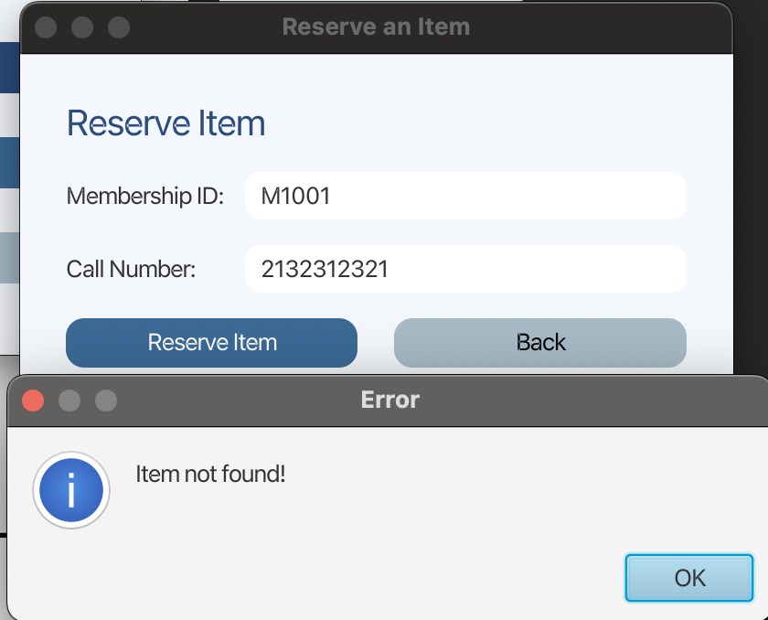

When an item is already reserved by another user, the system will show an error:

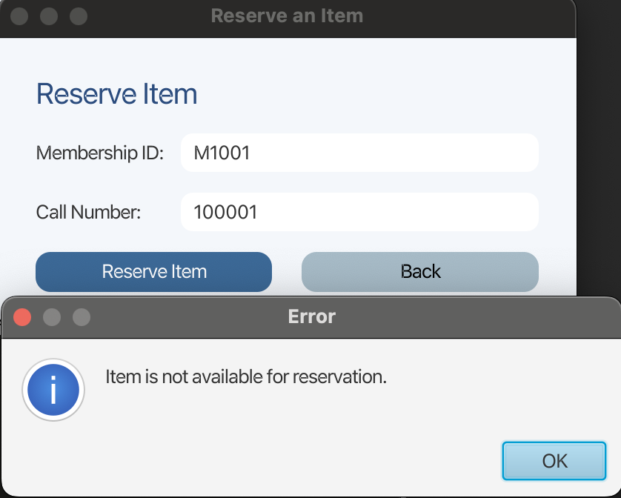

When a library member reaches the maximum number of reservations (3), the system shows an error:

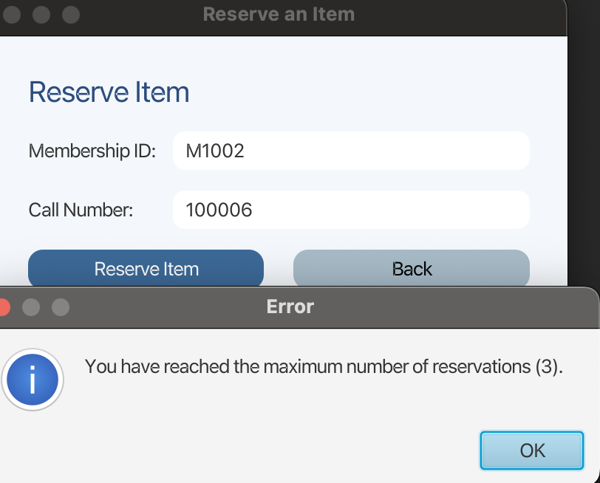

#### 5.3.2. Successful Item Reservation:

When a valid library member reserves a valid item, the system will show a success message with the total number of reservations, and the item will be marked as “Reserved” and it cannot be reserved by other members.

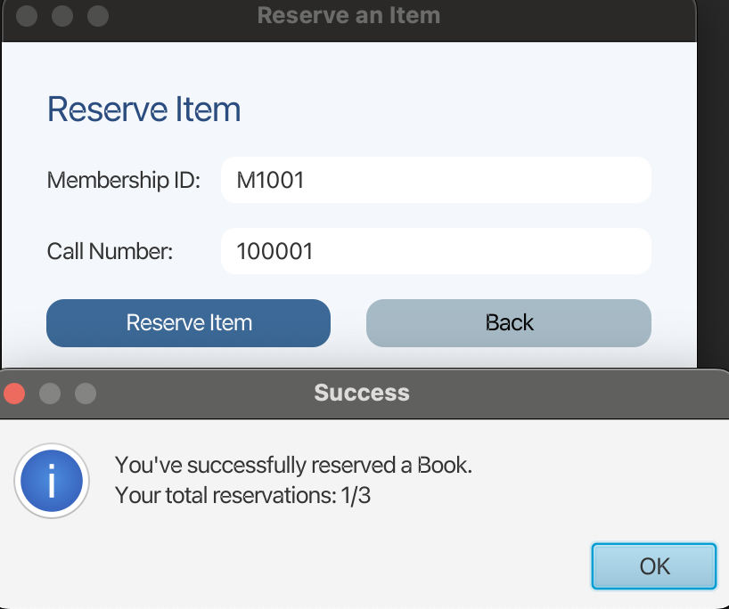

## 6. Task 4: Testing the Program Using JUnit Testing:

### 6.1. MembershipControllerTest:

#### 6.1.1. Test Methods & Explanations:

* **testSuccessfulMembershipApplication**: Verifies successful application, confirms the method returns true, the member count increases, and the membership fee is correctly deducted from the user's account, updating their status to ""Yes"".
* **testFailedApplicationInsufficientFunds:** Tests the financial guardrail, confirms the application fails (false) if the user's balance is less than the required fee and verifies the account balance remains unchanged.
* **testFailedApplicationAlreadyMember:** Ensures uniqueness, confirms the application fails (false) if the user is already registered as a library member and verifies the total member count is unchanged.
* **testFailedApplicationExternalStatus:** Enforces eligibility, confirms the application fails (false) when the user selects the ineligible status of ""External"".
* **testFailedApplicationInvalidUniversityMember:** Validates authentication, confirms the application fails (false) if the provided University ID/Finance ID does not exist in the university records.

#### 6.1.2. Test Results:

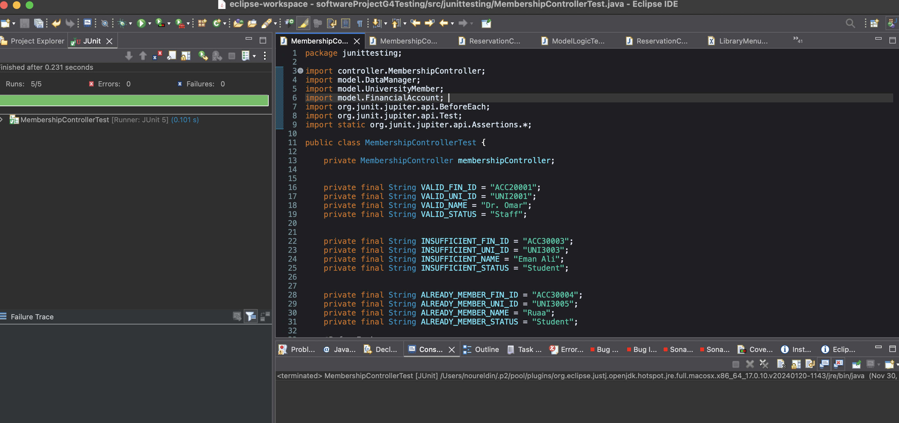

### 6.2. ModelLogicTest:

#### 6.2.1. Test Methods & Explanations:

* **testSuccessfulDeduction:** Verifies the core UniversityMember.deduct method, ensures the amount is correctly reduced when sufficient funds are available.
* **testFailedDeductionInsufficientFunds**: Verifies the financial transaction integrity, ensures the deduction fails (false) and the amount remains unchanged when the requested fee exceeds the balance.
* **testIsNewUniversityId_True**: Verifies ID tracking, confirms the administrative system correctly identifies a new, unregistered University ID.
* **testIsNewUniversityId_False**: Verifies ID tracking, confirms the administrative system correctly identifies an existing, registered University ID.
* **testRegisterUniversityId**: Tests the ID management process, confirms a new ID can be successfully registered and is then correctly recognized as a valid, existing member ID.

#### 6.2.2. Test Results:

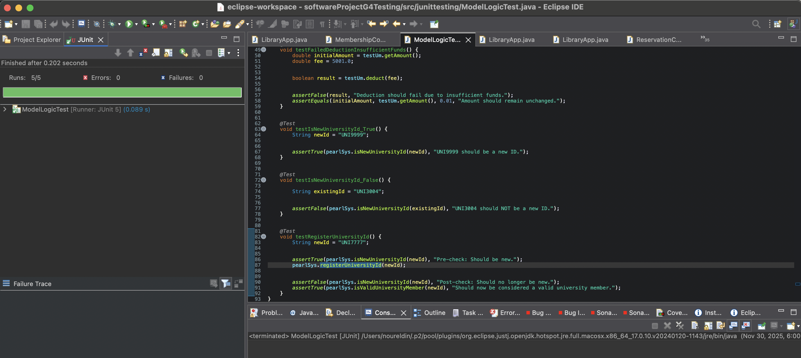

### 6.3. ReservationControllerTest:

#### 6.3.1. Test Methods & Explanations:

* **testSuccessfulItemReservation**: Verifies successful reservation, confirms the reservation succeeds (true) for an available item and an eligible member, and the member's reserved count increases by one.
* **testFailedReservationLimitReached**: Enforces the borrowing policy, confirms reservation fails (false) when the member has reached the maximum limit of 3 reserved items.
* **testFailedReservationItemAlreadyReserved**: Ensures item availability, confirms reservation fails (false) for an item that is already marked as reserved by another member.
* **testFailedReservationInvalidMemberId**: Validates member identity confirms reservation fails (false) when a non-existent Membership ID is provided.
* **testFailedReservationInvalidCallNumber**: Validates item identity, confirms reservation fails (false) when a non-existent item Call Number is provided.
* **testSequentialReservationsAndCounterIntegrity**: Verifies counter consistency, checks that three sequential successful reservations result in the member's total reserved count being exactly 3.
* **testBoundaryLimitEnforcement**: Tests the limit boundary, confirms that after a member reaches the limit of 3, any subsequent attempt to reserve (a 4th item) fails (false) and the counter correctly remains at 3.

#### 6.3.2. Test Results:

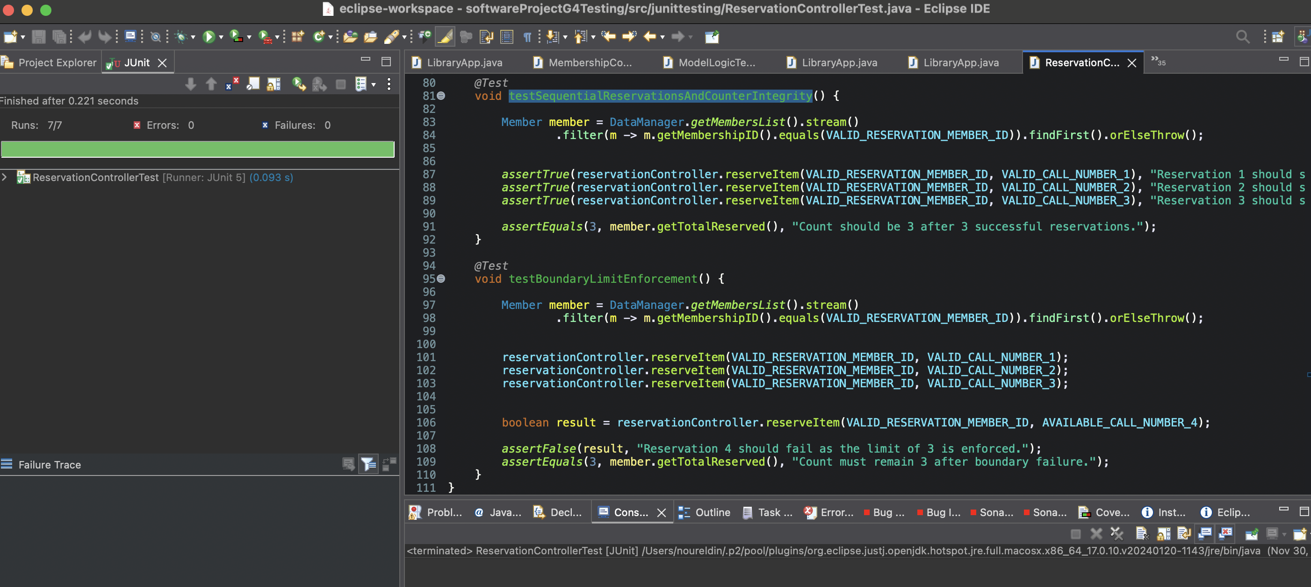

## 7. Task 5: Testing two Quality Requirements (NFRS):

### 7.1. Usability:

The Gulf Pearl University Library System is designed to provide users with a simple, intuitive, and efficient interface that allows them to complete tasks smoothly. Usability was evaluated using the *Hallway Testing* approach, where participants interacted with the system and then completed a survey assessing the ease of use, clarity of the interface, and overall experience.

Users were asked to respond to the following questions:

* How quickly did you understand how to use the system?
* Did the layout and controls feel clean and straightforward?
* How easily did you complete the actions assigned to you?
* Did the system react promptly to your actions?
* How satisfied were you with your overall experience interacting with the interface?

The survey results show that the system demonstrates solid usability, with users completing tasks efficiently and expressing high levels of satisfaction. Participants reported that the interface was easy to understand, navigation was smooth, and the system responded quickly to their actions. Overall, the feedback confirms that the system successfully supports an intuitive user experience.

|  |  |
| --- | --- |
| Survey Questions | Rating Average |
| Understanding How to Use the System | 4.8 / 5 |
| Clean & Straightforward Layout | 4.3 / 5 |
| Ease of Completing Actions | 4.4 / 5 |
| System Responsiveness | 4.4 / 5 |
| Overall User Experience | 4.6 / 5 |

In the next page it shows screenshots of the user results.

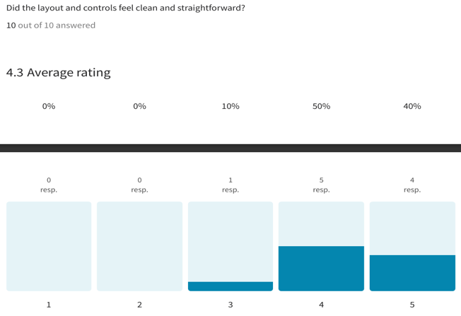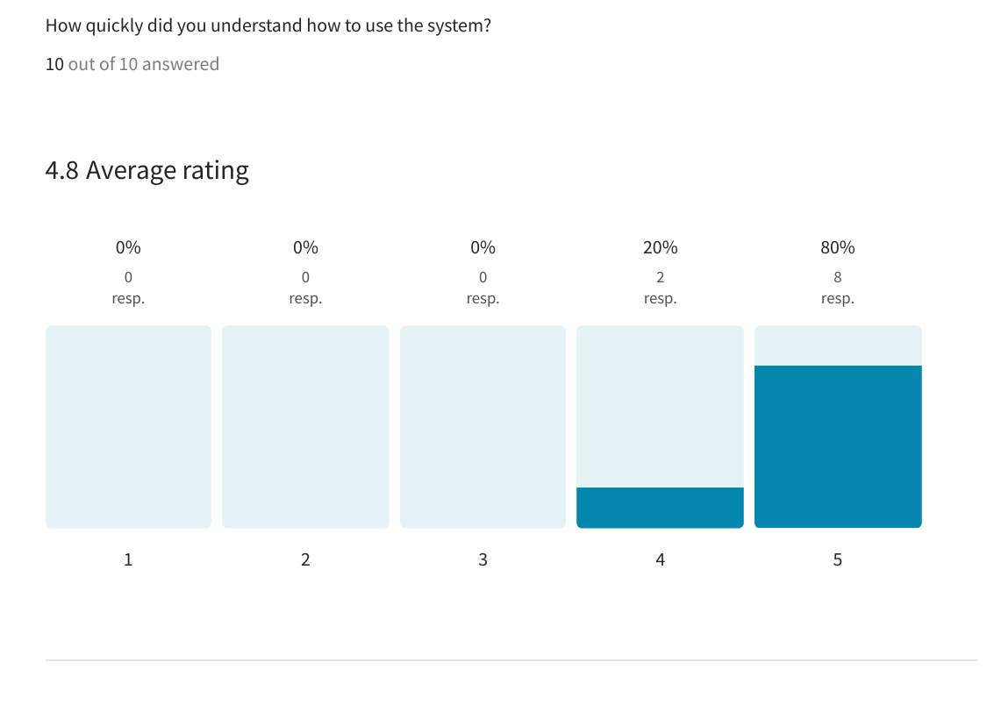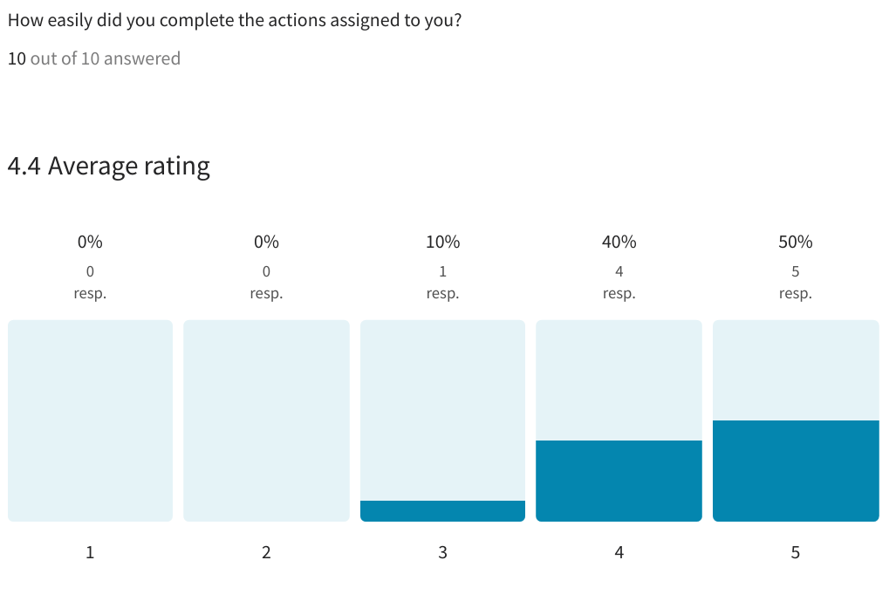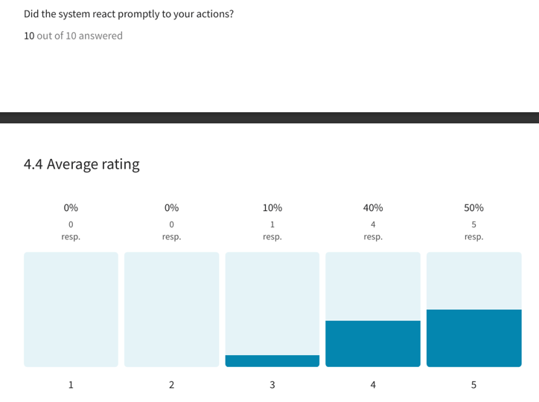

Figure 2: Did the layout and controls feel clean and straightforward

Figure 3: How easily did you complete the actions assigned to you

Figure 1: How quickly did you understand how to use the system

Figure 4: Did the system react promptly to your actions

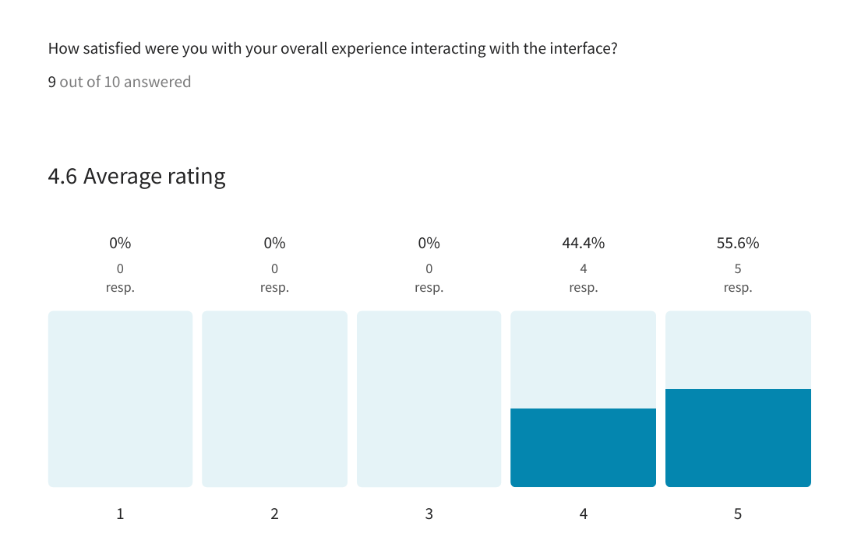

Figure 5: How satisfied were with your overall experience interacting with the interface

### 7.2. Reliability:

The system can handle errors and incorrect inputs and inform the user with an error message without data loss or user session disruption. Reliability has been tested by simulating invalid data and inaccurate inputs. The test shows the system's ability to handle failures without crashing during error handling.

#### 7.2.1. Error Prevention and Validation (Input Integrity):

* **Input Validation:** All user inputs (Name, Address, IDs, Call Numbers, amounts) must be checked against defined rules (e.g., format, range, existence).
* **Example:** The **Membership Application** now checks if the entered Name, Address, and Financial ID **match** the records in the university system, preventing invalid data from entering the library system.
* **Business Logic Enforcement:** Critical business rules must be enforced programmatically to prevent state errors.
  + **Example:** The system checks for sufficient funds via FinancialAccount.chargeFee() before finalizing a membership and limits reservations to three items via MAX_RESERVATIONS.

#### 7.2.2. Fault Detection and Isolation (Runtime Errors):

The system must quickly identify errors during execution and isolate them to prevent widespread failure.

* **Exception Handling (Code Layer):** All critical operations (like file I/O in DataManager, database lookups, and financial transactions) must be wrapped in try-catch blocks to prevent application crash.
* **Example:** DataManager. loadMembers() handles IOExceptions to ensure the application starts even if a data file is corrupted or missing.
* **Boundary Checking:** Explicitly checking for boundary conditions (e.g., maximum number of reservations) and handling them with clear error messages (showAlert) rather than letting the logic fail silently.

#### 7.2.3. Error Recovery and Data Integrity (Persistence):

* The system is designed to recover from errors and maintain a consistent state, particularly with persistent data.
* **Atomicity in Transactions:** Operations that modify multiple data stores (like applying for membership, which affects Members.txt and universityMembers.txt) should be designed so that if one step fails (e.g., FinancialAccount. chargeFee), the entire operation is rolled back, ensuring a consistent state.
* **Data Persistence:** The DataManager.saveAllToFile() method is called at critical points (application exit in LibraryApp.stop()) to ensure that all validated state changes persisted to disk, protecting against sudden termination or power loss.
* **Informative Alerts:** All errors, whether caused by insufficient funds, invalid IDs, or limits being reached, are converted into user-friendly Alert messages, providing immediate feedback and guidance on correction.

Here are the informative alerts:

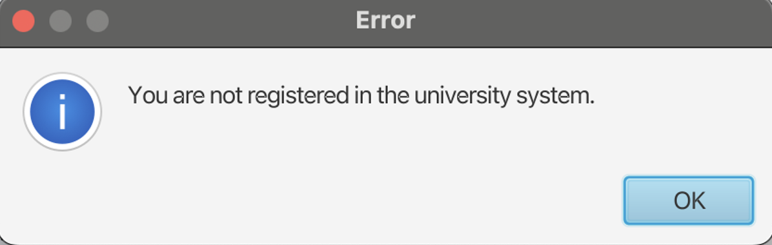

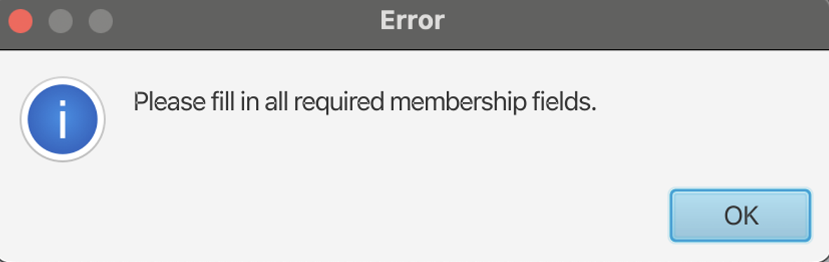

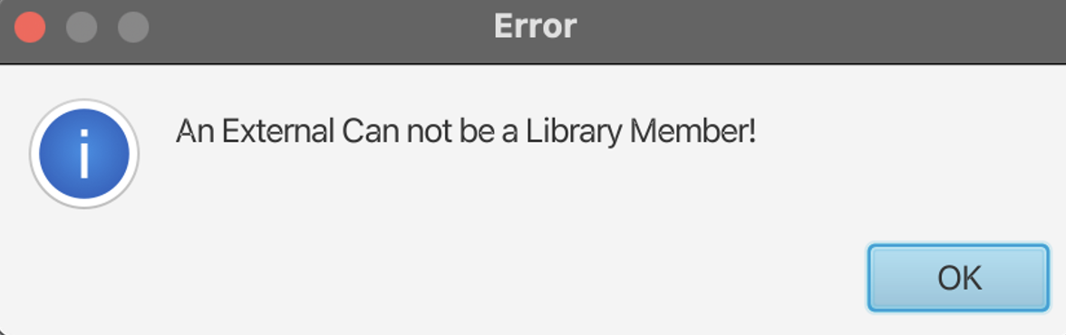

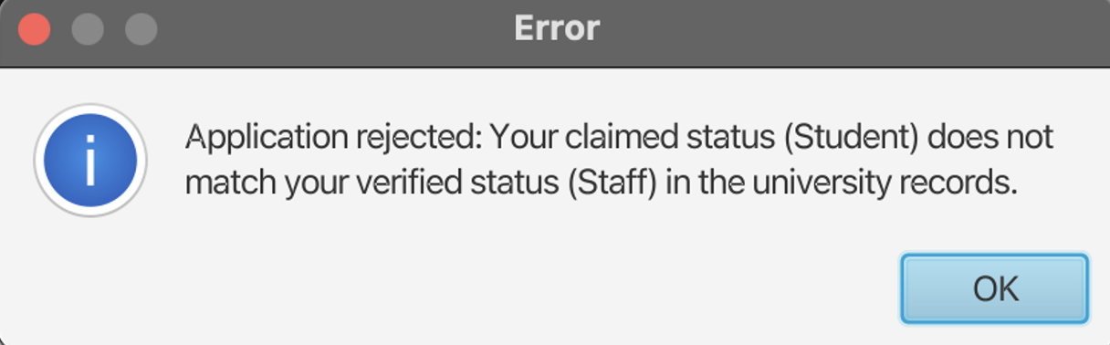

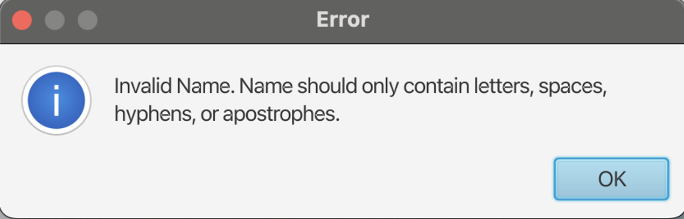

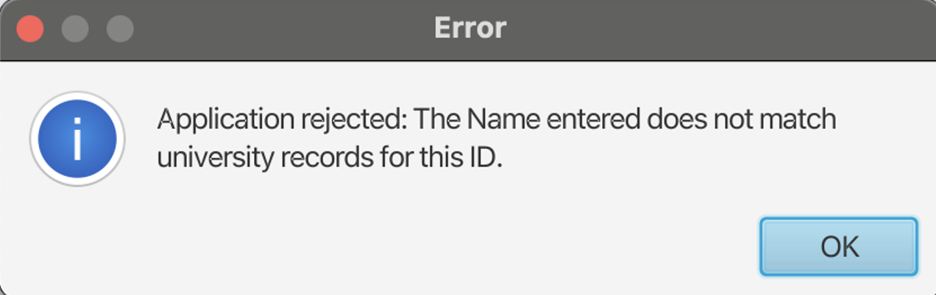

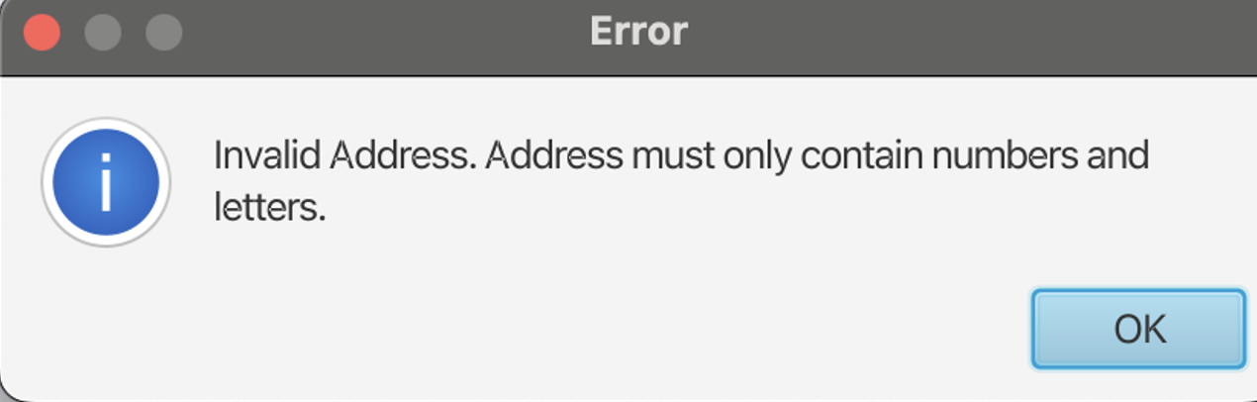

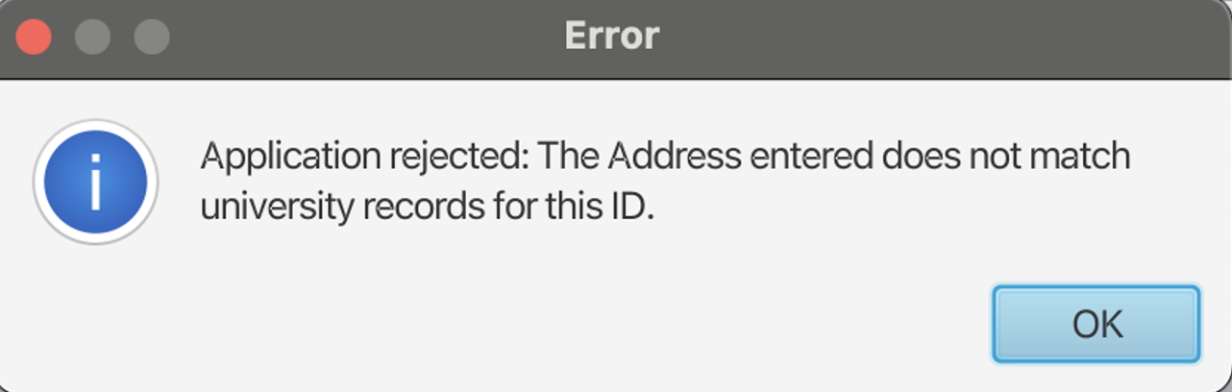

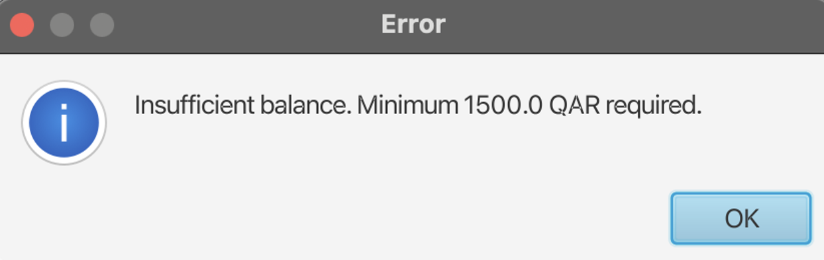

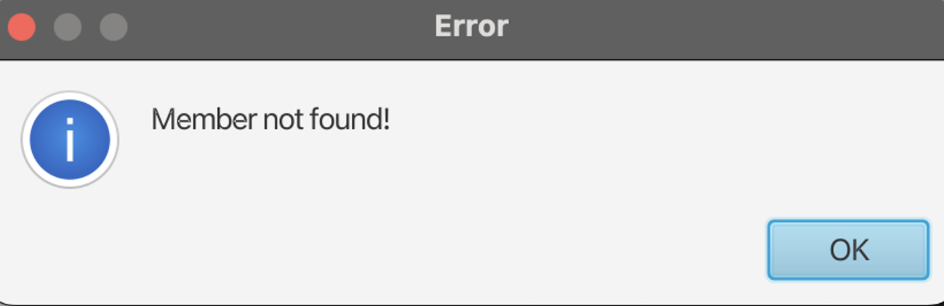

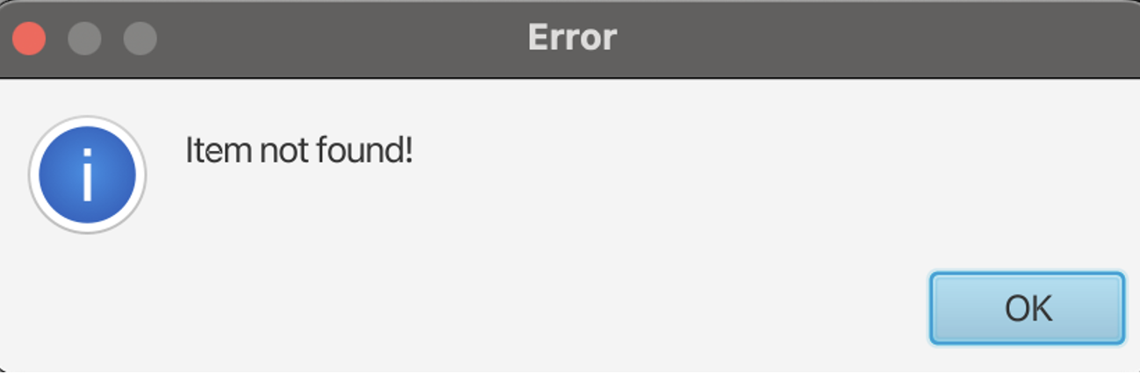

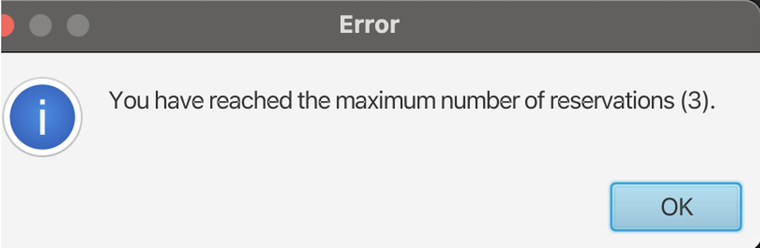

## 8. Task 6: Applying two Design Patterns:

### 8.1. Factory Pattern

#### 8.1.1. Justification:

* **Simplifies Object Creation**
* The client only calls **one method**: ItemFactory.createItem().
* The factory decides which subclass to create (Book, Magazine, DigitalMedia).
* **Removes Repeated** new **Statements**
  + Without the factory, every part of the program would need code like  
    new Book(...), new Magazine(...), etc.
  + The factory centralizes this in one place.
* **Makes the System Scalable**
  + If new item types are added (e.g., DVDs, Newspapers),  
    only the factory needs to be updated, **not the entire system**.
* **Improves Maintainability**
  + Item creation logic stays consistent.
  + Helps avoid errors from incorrect object initialization.
* **Reduces Coupling**
  + The client doesn’t need to know these classes exist:
  + Book
  + Magazine
  + DigitalMedia
  + It just asks the factory for an item, and the factory returns the correct one.

#### 8.1.2. Code & Explanation:

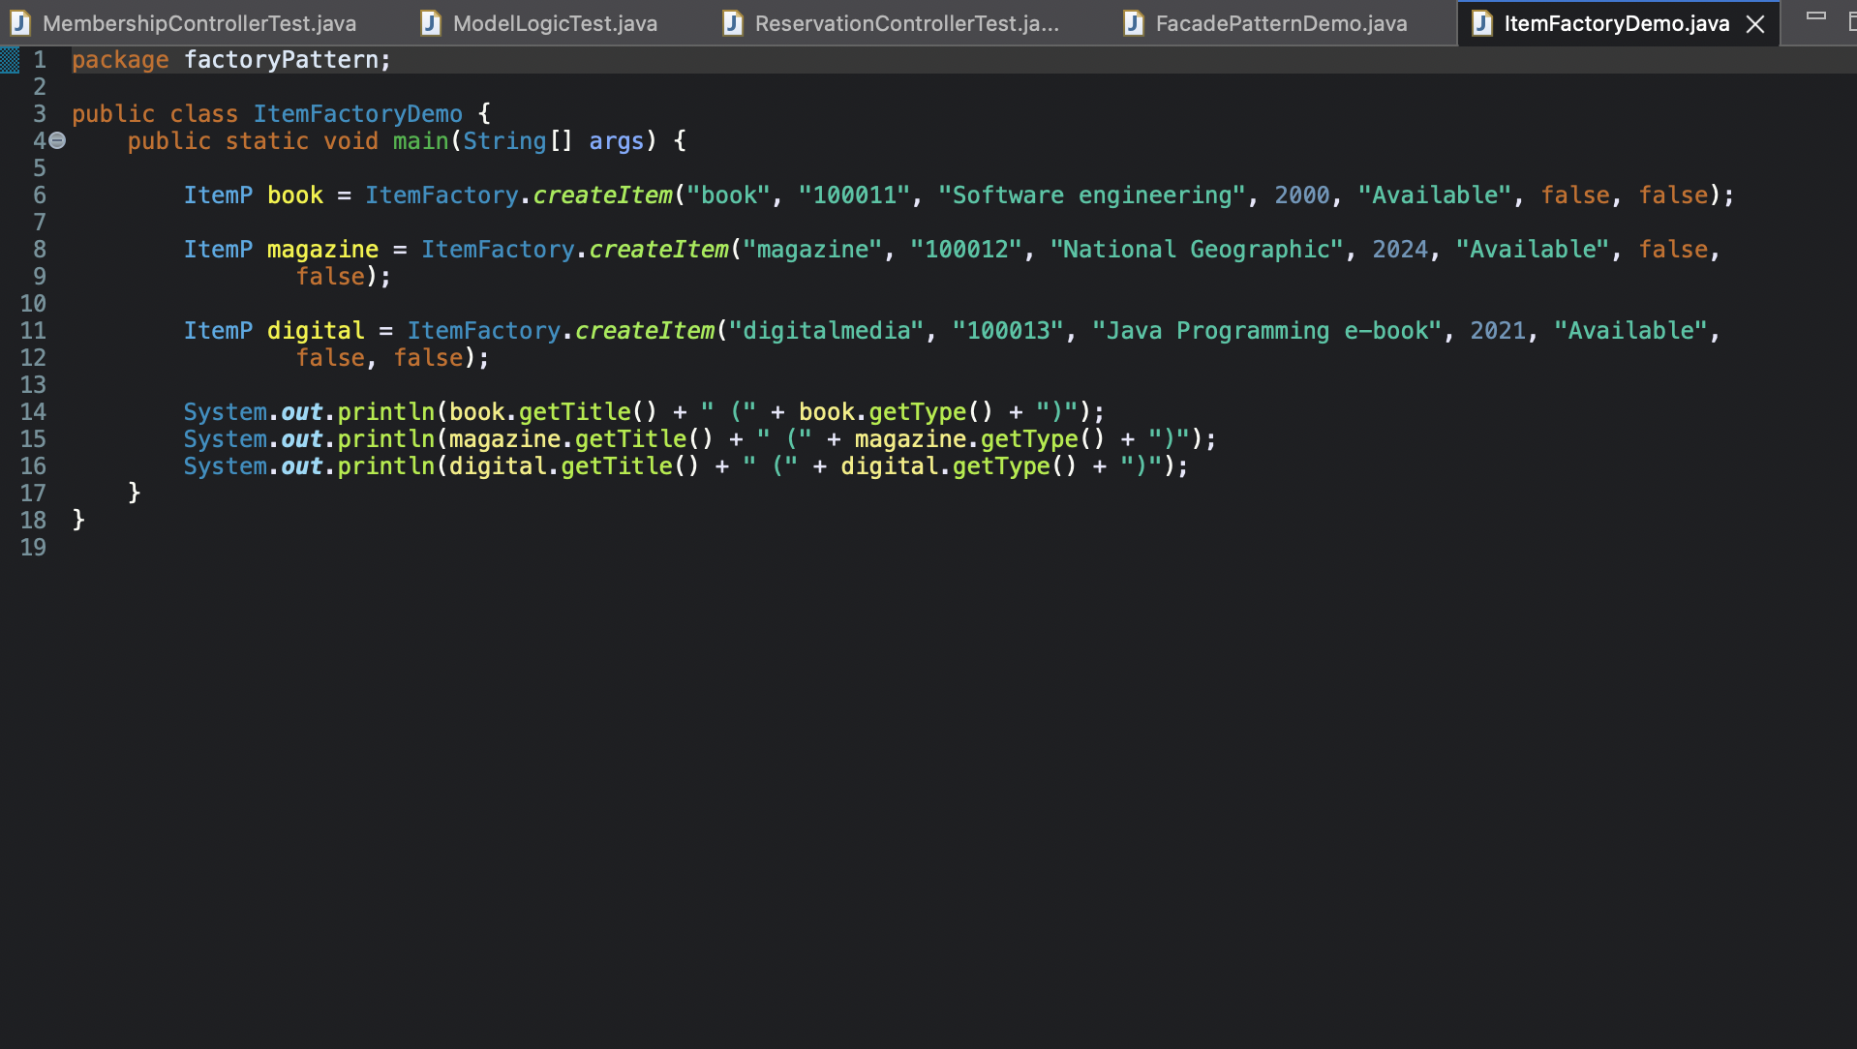

* **ItemP (Abstract Class)**
  + The base class for all item types.
  + Holds shared fields: title, callNumber, status, reserved/borrowed flags.
  + Book, Magazine, and DigitalMedia all inherit from this.
  + **Book, Magazine, DigitalMedia**
  + These are specific item types.
  + Each one calls super() to initialize shared item data.
* **ItemFactory**
  + Contains one public method:
  + createItem(String type, ...)
  + It checks the type and returns the correct object:
  + "book" → new Book(...)
  + "magazine" → new Magazine(...)
  + "digitalmedia" → new DigitalMedia(...)
  + If the type is unknown, it throws an exception.
* **ItemFactoryDemo**
  + Demonstrates the factory in action.
  + Creates:
  + A book
  + A magazine
  + A digital media item
  + Prints their titles and types.

#### 8.1.2. Results & Explanation:

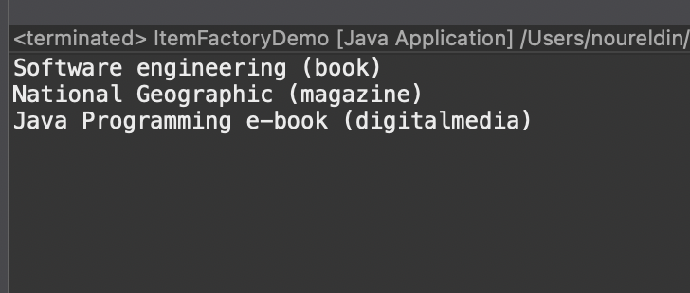

This output confirms that:

* The factory successfully created each object.
* Each item is stored with the correct type and title.
* The client code does not manually instantiate subclasses—everything is done by the factory.

### 8.2. Facade Pattern:

#### 8.2.1. Justification:

The Facade Pattern was used in this project to improve the structure and usability of the library management system. Its purpose becomes clearer when broken down into key benefits:

* **Simplifies a Complex System**
  + The system has multiple controllers, data lists, and operations.
  + Without a facade, the main program would need to call many different classes directly.
  + The facade provides **one clean access point** for everything.
* **Reduces Coupling**
  + The client doesn’t need to know how membership or reservation logic works internally.
  + If the internal controllers change, the facade interface can stay the same.
  + **Makes the Code More Readable**
  + Methods like applyForMembership(), reserveItem(), and getItemType() are simple and clear.
  + The internal logic behind them is hidden, making the external API easy to understand.
* **Centralizes Common Operations**
  + All library-related actions are grouped into one class: LibraryFacade.
  + This helps maintain a consistent flow across the system.
* **Improves Maintainability & Modularity**
  + Controllers can be modified or extended without affecting the main program.
  + The facade acts as a “layer of protection,” preventing external code from depending on low-level classes.

#### 8.2.2. Code & Explanation:

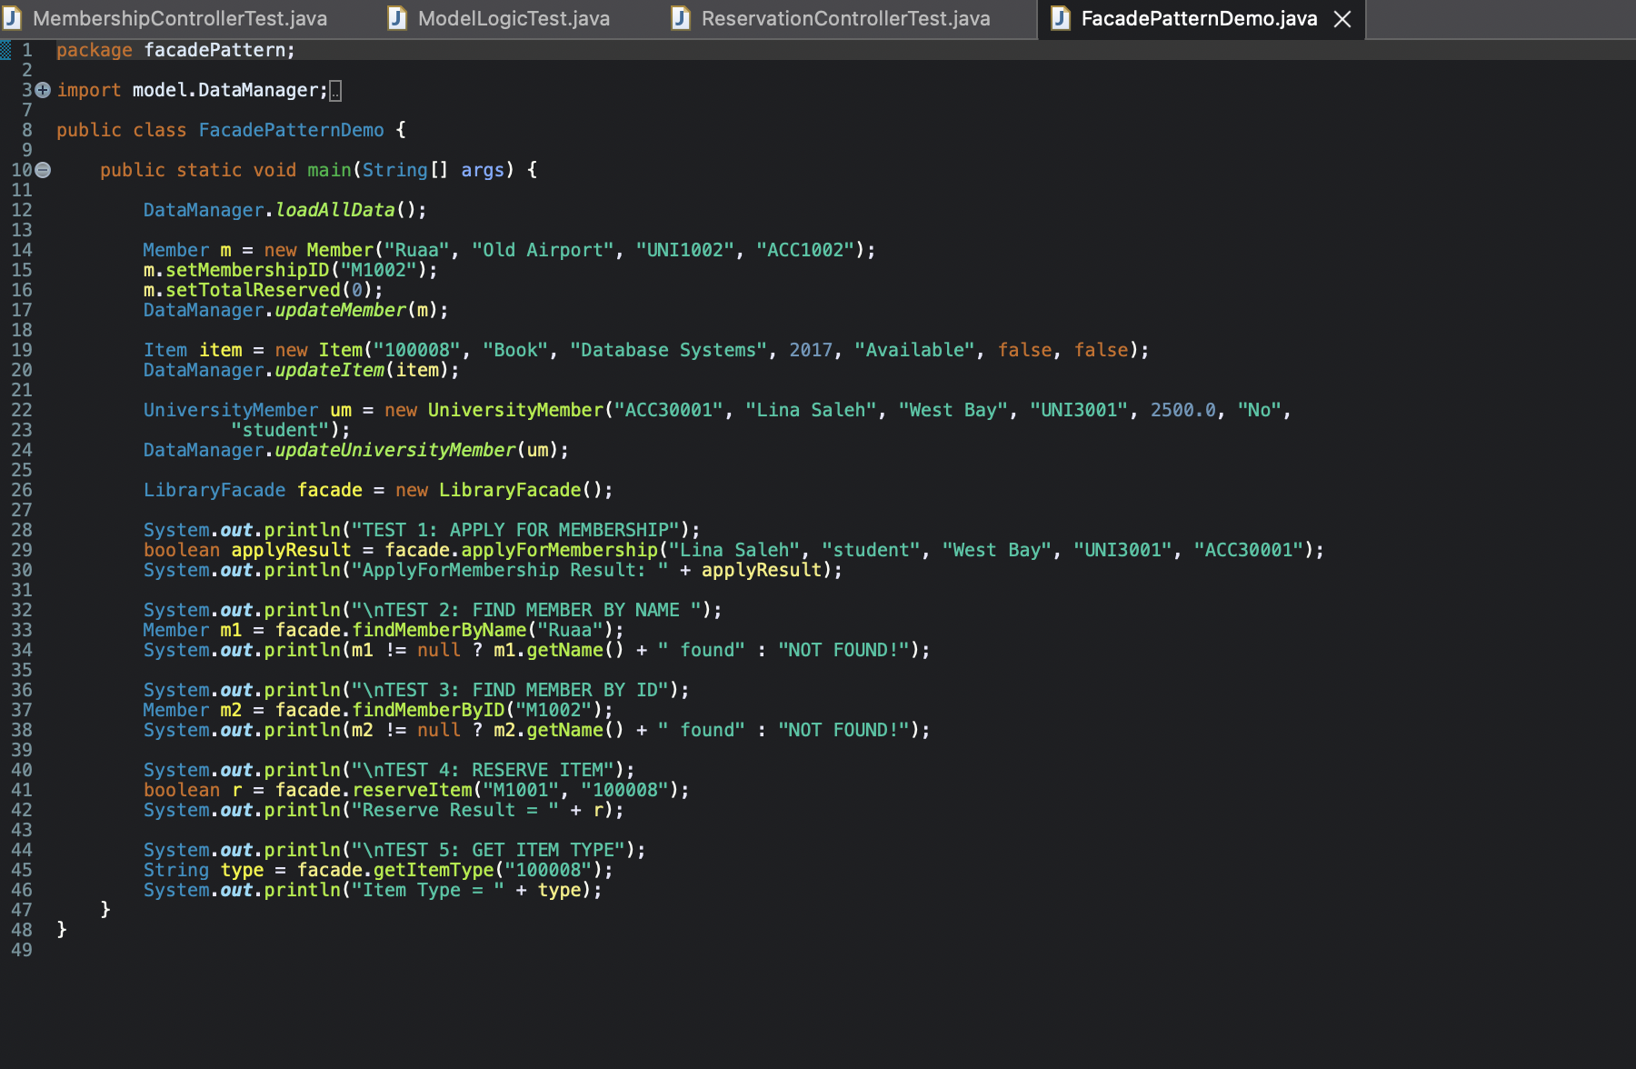

The project uses a LibraryFacade class that acts as the single-entry point to the entire library system.

Inside the facade, two controllers are used:

* **MembershipController**: handles member creation, searching, and validation.
* **ReservationController**: handles item reservation, searching for items, and item type retrieval.

The facade exposes easy methods like:

* applyForMembership(...)
* findMemberByName(...)
* reserveItem(...)
* getItemType(...)

Each of these methods calls the correct controller behind the scenes.  
This means the client (main method) only interacts with LibraryFacade, not with 5–6 different classes.

#### 8.2.3. Results & Explanation:

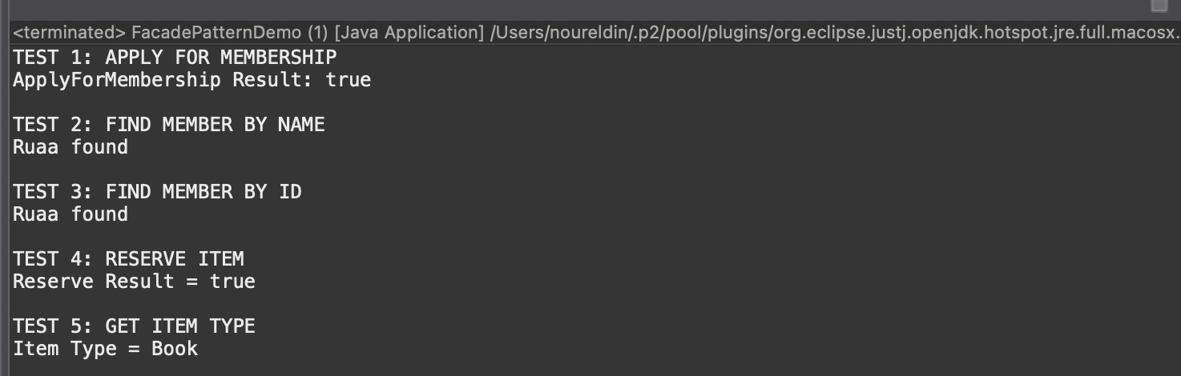

* **DataManager loads all data**
  + Pre-existing lists of items, members, and university members are loaded.
  + **The program creates sample data**
  + A new member, item, and university member are added for testing.
* **TEST 1: APPLY FOR MEMBERSHIP**
  + The facade checks:
  + UniversityMember exists
  + They have enough money
  + They don't already have a membership
  + If everything is valid, the membership is created.
  + Output: ApplyForMembership Result: true or false depending on data.
* **TEST 2: FIND MEMBER BY NAME**
  + Facade calls findMemberByName("Ruaa").
  + If found, prints:  
    "Ruaa found"
  + If not, prints "NOT FOUND!"
* **TEST 3: FIND MEMBER BY ID**
  + Facade searches by membership ID.
  + Output shows whether the member exists.
* **TEST 4: RESERVE ITEM**
  + Facade asks ReservationController to reserve item 100008 for member M1001.
  + It checks:
  + Member exists
  + Member is allowed to reserve
  + Item is available
  + Output shows success or failure.
* **TEST 5: GET ITEM TYPE**
  + Facade retrieves item info through ReservationController.
  + Output: Item Type = Book(or whatever type the item has).

# Section 3:

## 9. Conclusion:

To conclude, working on this Library Management System taught us a lot more than we expected. When we first started, our goal was mainly to build a system that could make basic library tasks like adding books, borrowing, returning, and managing users easier and more organized. But as we continued developing it, we realized how important it was to design the system in a structured and professional way. Applying the Factory and Façade patterns wasn’t just something we added because it was required; it helped us improve the system’s performance, organization, and flexibility.

Throughout the project, we learned how each pattern plays a real role in solving common software problems. The Factory Pattern made it simple to create different types of objects without repeating code everywhere. The Facade Pattern made the system feel much cleaner by giving one simple entry point to deal with several functions behind the scenes.

Overall, this project helped us understand not only how to build a working library system, but also how to design software with better structure and better thinking. It was a challenging experience at some points, but it helped us grow as students and developers. By the end, we were able to connect what we learned in theory with something practical and useful, and that made the whole process meaningful.

## 10. Resources:

### 10.1. GitHub Link:

[CMPS310Fall25/cmps310-project-team-b54-g04: cmps310-project-team-b54-g04 created by GitHub Classroom](https://github.com/CMPS310Fall25/cmps310-project-team-b54-g04)

### 10.2. Snapshot from GitHub Page:

